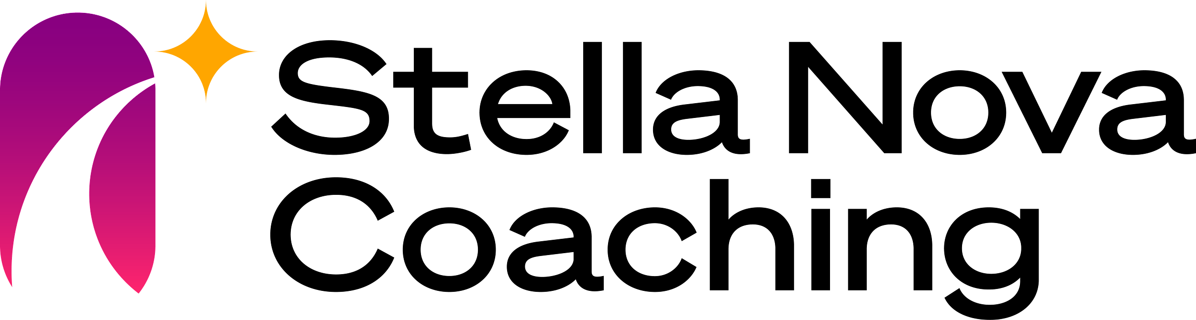**Exploratory Networking**

**Initial Targets:**

* Easy
  + A friend
  + Someone you know
  + Someone who has been referred to you
* Harder
  + Someone you have read about
  + Anyone you can identify who works for an interesting organization or has an interesting job

**Start with a simple email**

It's important for you to make the message authentically your own, but here are a few guidelines:

* If you know the person (even a little bit), give some context for who you are and how you know them.
  + “It was great to meet you at the Hill briefing last week.”
  + “It’s been a while since we connected. I hope things are going well.”
* If you don’t know the person, introduce yourself.
  + “My name is Kirk McIntire. Mark Twain at the Administration on Something suggested that I reach out to you.”
  + “My name is Mike Perry. I found your name on the XYS website and wanted to reach out.”
* Follow that with a quick comment about what drew your attention to them (the more specific you can be, the better) and the purpose of your email. Say what it is about the organization, their work, their mission, etc. that you find interesting.
  + “Mark told me about the innovative work you’re doing around artificial intelligence, and I’d love to find out more.”
  + “I read about the entrepreneurship program you’re managing and how you’re using storytelling and emotional intelligence principles. That’s right in line with my interests, and I’d love to learn more.”
* Start a new paragraph and say a little bit about who you are.
  + “I am currently working at XXXXX focused on XXXX. Since graduating from Lake Erie University in 2022, I have been fascinated by the potential of bringing nontraditional and innovative elements into the world of small business.”
* Ask specifically for a 30-minute call to hear their opinion/perspective/advice. Remember that the sub-text of your message is that they are important and have done impressive things.
  + “Would you have 30 minutes for a phone or Zoom conversation sometime over the next two weeks? I’d like to hear more about what you’re doing as well as how you came to be involved in this area.”
* Leave a clear but polite impression that you ARE going to have the conversation.
  + “Please let me know what day and time would work for you.”
  + “I will call your offices in a few days to follow up.”
* Thank them ahead of time.
  + “Thank you in advance for sharing your time and insight. I look forward to speaking with you soon.”

Again: It's important for you to make the message authentically your own!

**During the meeting**

* Do a bit of research and come prepared with questions.
  + What do you enjoy about the work you do?
  + I read that the program has grown dramatically over the past couple of years. What difference has that made to XXXXX?
  + What more would you like to be doing that would increase your impact?
* Stick to the 30-minute agreement. If they ask to speak longer, play that by ear, but don’t assume they’re OK extending the time just because they aren’t stopping the conversation.
* Share some things you’ve worked on that have fired you up. Share your passion as it relates to what they do.
* **IMPORTANT:** **Always… ALWAYS** ask who else they would suggest you talk with. Ask for at least two other names. If they say they need to think about it and will send the names to you later, remind them in your follow up thank you email.

**After the meeting**

* Send them a thank you email either the same day or the next day. Mention something specific that you talked about. Thank them for both their time AND their insight, information, perspective, advice, etc.
* Reach out to each new referral within two days with an introductory email and start the process over again.
* Check in with the original contact after 2-3 weeks. Thank them again and mention how things went with the people they referred you to. Give them an update on your progress.
* Check in with them a couple of months later and every quarter or so thereafter. Just a short email is all that’s necessary to give them a quick update and remind them that you exist and that you’re awesome!

**Key things to keep in mind while networking**

* **You are NOT looking for a job.** You are only looking for information and to gain a broader perspective on the type of program/field/organization/mission you might be interested in.
  + If the people you’re reaching out to think you’re asking about possible job openings, that is a closed (yes or no) question and a super easy way to end a conversation quickly.
* Ask primarily open-ended questions … about the organization, what the person enjoys about their job, what first got them interested in *XXX*, what they think the future of area of work is, etc. These kinds of questions are limitless and will lead to much better and richer conversations.
* You will impress your connections with your questions, your demeanor, your energy, your professionalism, your follow up, and your persistence. As you do this more and get increasingly comfortable, it will become more and more natural and authentic.
  + If you show up authentically and don’t impress them – if there’s no ‘click’ – then there’s no use spending any more time on that connection. Move on to the next one. You will have more than enough to keep you busy.